CURRICULUM VITAE

NAME: SHRABANI THOKDAR 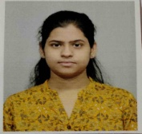
CONTACT NO: 9547163060
Mail ID: shrabanithokdar090@gmail.com
DATE OF BIRTH: 23/07/1997 (DD/MM/YYYY)
RELIGION: Hindu
GENDER: Female
CATEGORY: General
BLOOD GROUP: AB+
MARITAL STATUS: Unmarried
FATHER’S NAME: DOKARI THOKDAR
PERMANENT ADDRESS: Deshbandhu para, P.O.- Jhaljhalia, P.S.- English Bazar, Dist.- Malda, PIN No- 732102
LANGUAGES KNOWN: Bengali (Mother Tongue), English and Hindi
CAREER OBJECTIVE: Looking to obtain a position in an organization where I am able to put all my knowledge in practice. I firmly believe in the principle of implementing my duties with dedication and determination. I am looking for good career growth opportunities where my talent and knowledge could be best subjected and utilized for the benefit of organization and myself.

ACADEMIC QUALIFICATION:
Name of Examination | Board/University | Year of Passing | % of marks obtained
Madhyamik | W.B.B.S.E. | 2013 | 77.71
Higher Secondary | W.B.C.H.S.E. | 2015 | 85.02
B.A. (Honours) in English Literature | Gour Banga University | 2018 | 61.25
M.A. in English Literature | Gour Banga University | 2020 | 66.08
B.Ed. | Govt. Teacher’s Training College, Malda (WBUTTEPA) | 2022 | 88.80

ADDITIONAL QUALIFICATION:
Name of the course | Passed from | Year of Passing
Diploma in Information Technology Application (DITA) | Yuva Computer Training Centre, Malda | 2016-2017

Additionally, I passed the PAPER-1 of the CTET Examination, 2023 held on 20.08.2023.
26.9.23 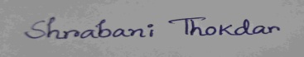
Date: Signature

