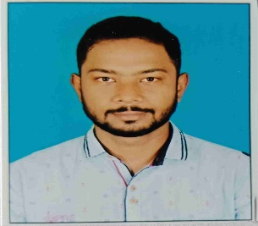
SUMON ROY | Address:Narayanpur,Narendranagar.  PO: R-Gopalpur  Kolkata – 700136  Mobile no:– 9123923243  Email:- roy.sumon8981@gmail.com

Objectives:
My aim is to work innovatively for the enhancement and betterment of education. I aspire to work for an institution which offers career growth and chances to learn and improve my knowledge.

Teaching Experience:

1. Eight years’ experienced as private tutor from class VIII-XII Mathematics (C.B.S.E, I.C.S.E, W.B)

2. Three years’ experienced as Mathematics faculty in Indian Force Academy (Competetive exam institute)

3. Two years’ experienced as PGT Mathematics at National English School.

B.ED (2021-2023)
Degree : B.Ed
College(University) : Institute of Human Excellence
University : West Bengal University of Teachers' Training, Education Planning and Administration

Percentage : 84.15

Masters Educational Details (2019-2021)
Degree : MSc. Mathematics
College(University) :The University of Burdwan
Subject : Mathematics
Percentage : 76.9

Graduation Educational Details (2013-2017)

Degree : BSc.(Math Honors)
University : West Bengal State University
Subject : Mathematics (Honors)
Pass Subject – Physics, Computer Science
Percentage : 49.75

Page 1

10th & 12th Educational Details :
Examination Board/Council Name of School Year of Percentage
Passing

Secondary W.B.B.S.E Bishnupur Sir Ramesh
Institution 2010 66.8

High Secondary W.B.C.H.S.E Chittaranjan Colony 2012 60
HIndu Vidyapith

Personal Details
Date of Birth : 11th Sep ,1993
Permanent Address : Narayanpur,Narendranagar,Natunpally.PO:R-gopalpur.Kolkata:700136
Nationality : Indian
Marital Status : Unmarried
Sex : Male
Language Skills : English, Hindi and Bengali
Phone No. : 9123923243

I am declaring that all the above information is true to the best of my knowledge and belief.


Date : 14/12/2023
Place : Kolkata --------------------------------------
(Signature)
Page 2

