RESUME
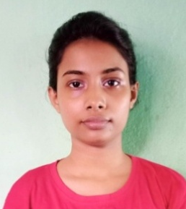

SUSMITA GHOSH
CONTACT NUMBER: 8777877613
EMAIL ID: susmitaghosh.smg@gmail.com
Objective
- Intend to build a career with educational institution desirable to work with dedicated employee in a hi-tech environment which will help me to improve my ability to work.
Professional Synopsis
- Basic computer course from NIELIT (DOEACC).
- Basic computer course from KABIGURU PATHBHABAN.
- Spoken English course from THE RAMAKRISHNA MISSION INSTITUTE OF CULTURE SCHOOL OF LANGUAGES, GOLPARK.
- Spoken English course from KABIGURU PATHBHABAN.
- Recitation from BANGIYA SANGEET PARISHAD, Registered under WEST BENGAL SOCIETIES REGISTRATION ACT, Affiliated to — RABINDRA BHARATI UNIVERSITY.
Employment Chronicle
- Experienced as a Pre primary teacher in both online and offline classes.

Professional Skills
Course Name | Session | Passed form | Affiliated by | % of Marks | Division
International Pre-Primary & Primary Teacher’s Training. | 2019  -  2020 | KABIGURU PATH BHABAN  An ISO 9001: 2015 Certified organization, Govt. Regd.  No. IV-190100189/2019 | IAO  (International Accreditation Organizations) | 92.5 % | Distinction
Pre-Primary Teacher’s Training. | 2019  -  2020 | NCS MINISTRY OF LABOUR & EMPLOYMENT | GOVT. OF INDIA  SKILL | 92.5 % | First Class
BSS  (Advance Diploma in Nursery & Primary Education) | 2019  -  2020 | BHARAT SEVAK SAMAJ | CENTRAL BOARD OF INDIA | 90 % | Distinction
Scholastic
Name of Exam | Year of passing | Board/ University | % of Marks
PG | 2017 | W.B.S.U. | 63.81 %
UG | 2015 | W.B.S.U. | 52.38 %
HS | 2012 | W.B.C.H.S.E. | 66.8 %
MP | 2010 | W.B.B.S.E. | 54.5 %
Language Known
Language | Can Speak | Can Write | Can Read
English | Yes | Yes | Yes
Bengali | Yes | Yes | Yes
Hindi | Yes | Yes | Yes

Extramural Engagement
- Recitation
- Art & Craft
- Drama

Personal Dossier
Date of Birth : 30/12/1994
Father’s Name : Late Madhusudan Ghosh
Mother’s Name : Smt. Aparna Ghosh
Nationality : INDIAN
Category : General
Sex : Female
Marital Status : Unmarried

Contact Details
Address : Duttapukur, Barasat, North 24 Parganas,
West Bengal, Pin code -743248
Mobile No. : 8777877613
Email Address : susmitaghosh.smg@gmail.com

Declaration
I hereby declare that the above mentioned information is correct up to my knowledge. I bear the responsibility for the correctness of the above mention particulars.

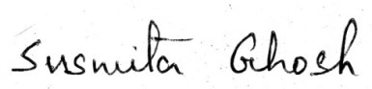
Date : 10-04-2021
Place : Barasat
Signature

