CURRICULUM VITAE
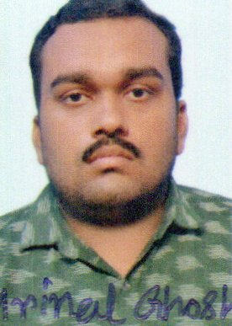 NAME : MRINAL GHOSH
PERMANENT AND CORRESPONDENCE ADDRESS:-
VILL : SRIPATIPUR BLOCK : HARIPAL STATE : WEST BENGAL
P.O : ILAHIPUR DIST : HOOGHLY
P.S : HARIPAL PIN : 712706
CONTACT DETAILS :-
MOBILE NO : 8944016301/8910864842
EMAIL ID : ghoshmrinal.s123@gmail.com / mrinalghosh.medical@gmail.com
PERSONAL DETAILS :-
GENDER : MALE FATHER’S NAME : SISIR KUMAR GHOSH RELIGION : HINDU
DATE OF BIRTH :25/05/1996 MOTHER’S NAME : SAHELI GHOSH NATIONALITY : INDIAN
MARITAL STATUS : UNMARRIED
CAREER OBJECTIVE :-
TO WORK FOR AN ORGANIZATION WHICH PROVIDE ME THE OPPORTUNITY TO IMPROVE MY SKILLS AND KNOWLEDGE TO GROWTH ALONG WITH THE ORGANIZATION OBJECTIVE.
PERSONAL SKILL:-
ABILITY OF WORK IN ANY SITUATION.
HARD WORKING AND PUNCTUAL.
COMMUNICATION IN DIFFERENT LANGUAGE LIKE HINDI, BENGALI , ENGLISH.

ACADEMIC QUALIFICATION: -
NAME OF EXAM BOARD INSTITUTE YEAR OF PASSING MARKS OBTAINED PERCENTAGE
SENCONDARY EXAM W.B.B.S.E SHEAKHALA 2012 580 OUT OF 700 82.85
BENIMADHAB
HIGH SCHOOL

HIGHER SECONDARY W.B.C.H.S.E SHEAKHALA 2014 393 OUT OF 500 78.60
EXAM BENIMADHAB
HIGH SCHOOL

B.SC HONOURS UNIVERSITY RAJA PEARY 2018 433 OUT OF 800 54.12
OF CALCUTTA MOHAN COLLEGE

B.ED (2 years) WBUTTEPA MAZIDIA ACADEMY 2021-23 AWAITING AWAITING
SESSION

CERTIFICATE SAHAJ 2018 90
IN COMPUTER RETAIL
APPLICATION LIMITED
(6 MONTHS)
COMPUTER KNOWLEDGE :-
ABILITY TO DO WORK IN MICROSOFT OFFICE , EXCEL, POWER POINT ,INTERNET , PAINT ETC.
I HEREBY DECLARE THAT THE ABOVE MENTION INFORMATIONS ARE TRUE TO BEST OF MY KNOWLEDGE.
I ATTACH BELOW THE SUPPORTING DOCUMENT OF MY CV.
DATE :- Sincerely,
PLACE :- SHEAKHALA, HOOGHLY,WEST BENGAL 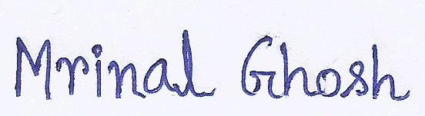
AADHAR CARD:-

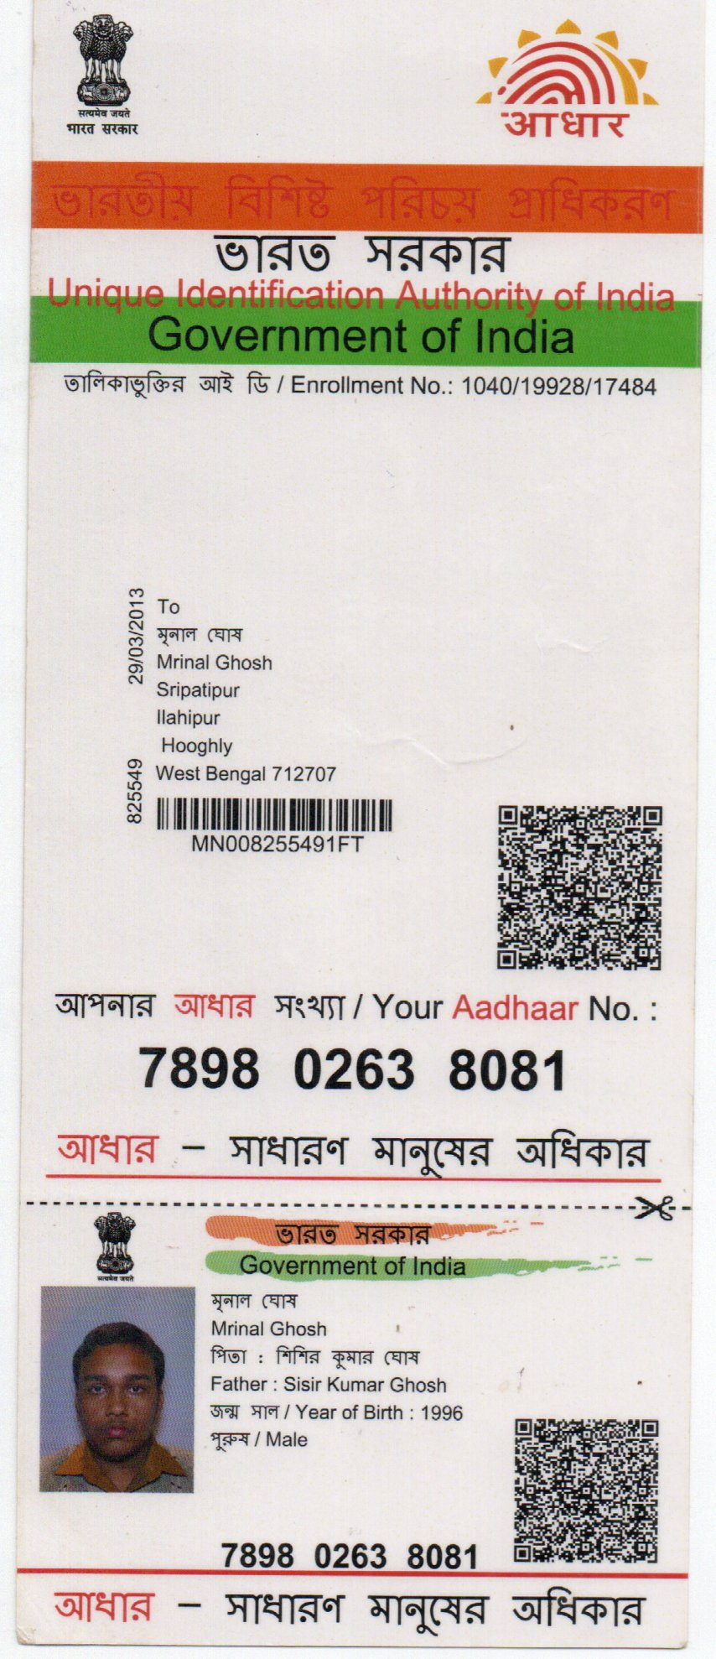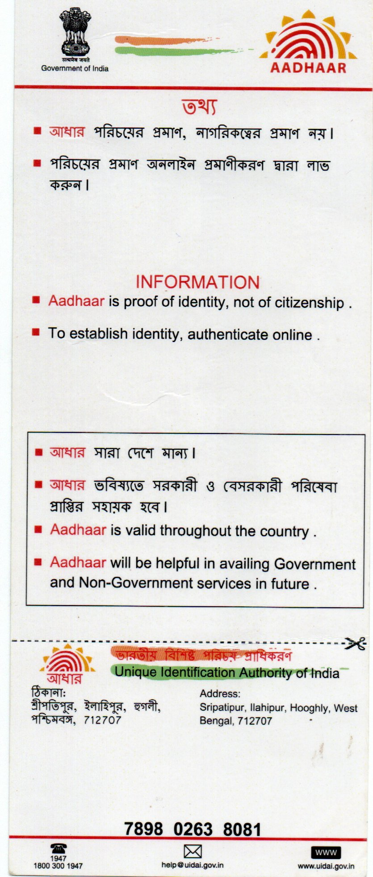

VOTER CARD :-
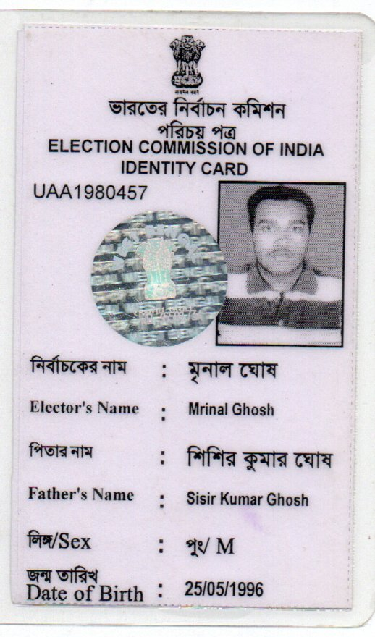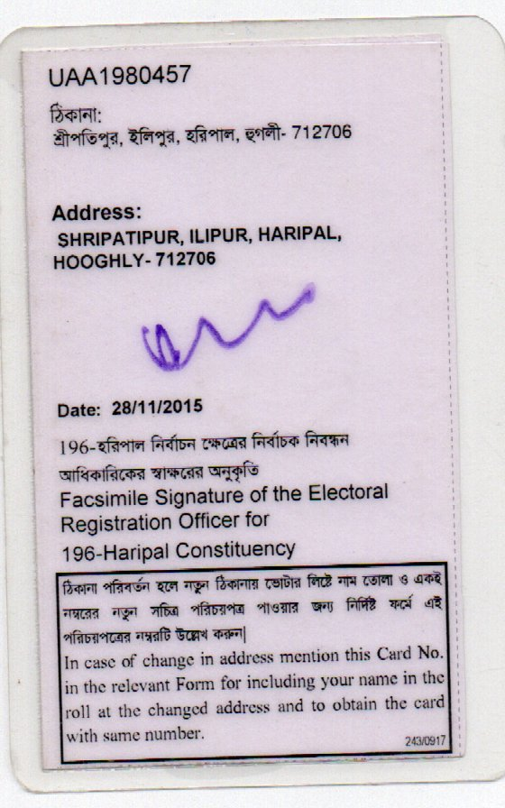

SECONDARY RESULT:-
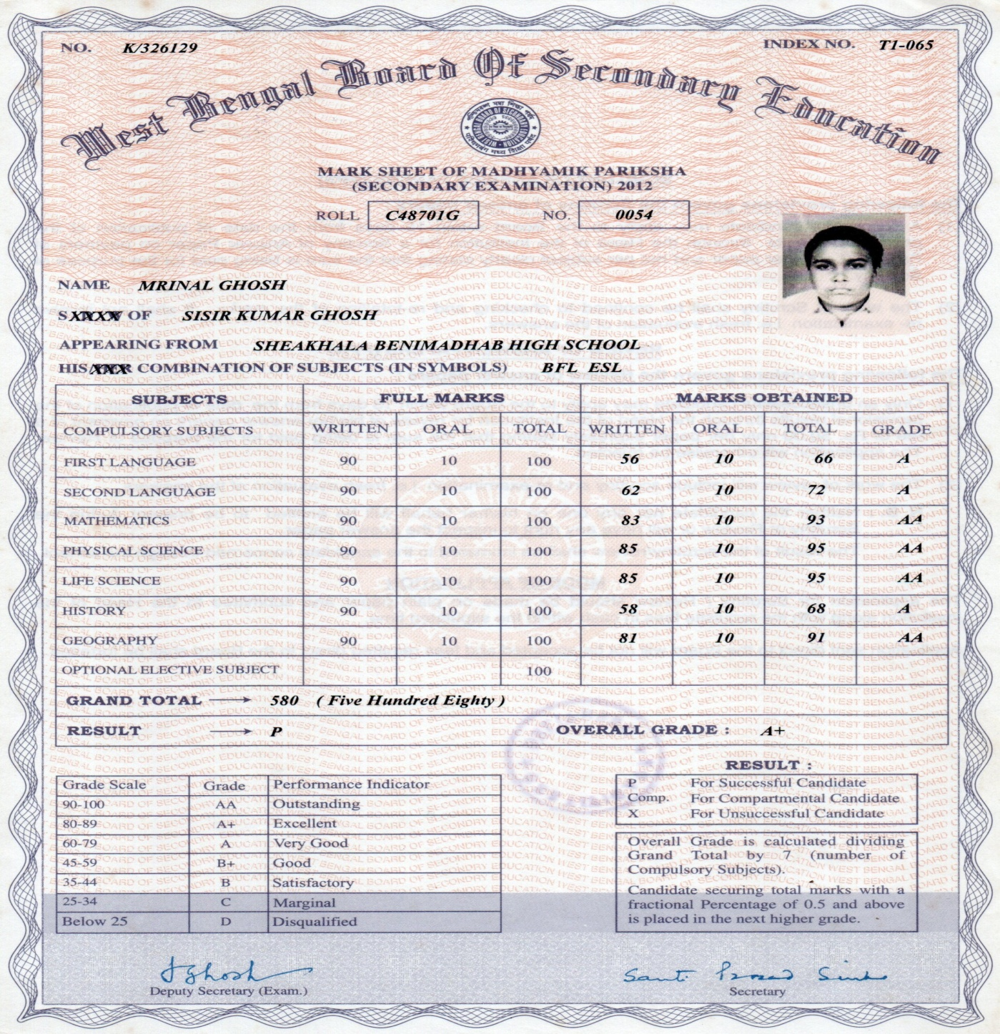

SECONDARY CERTIFICATE :-
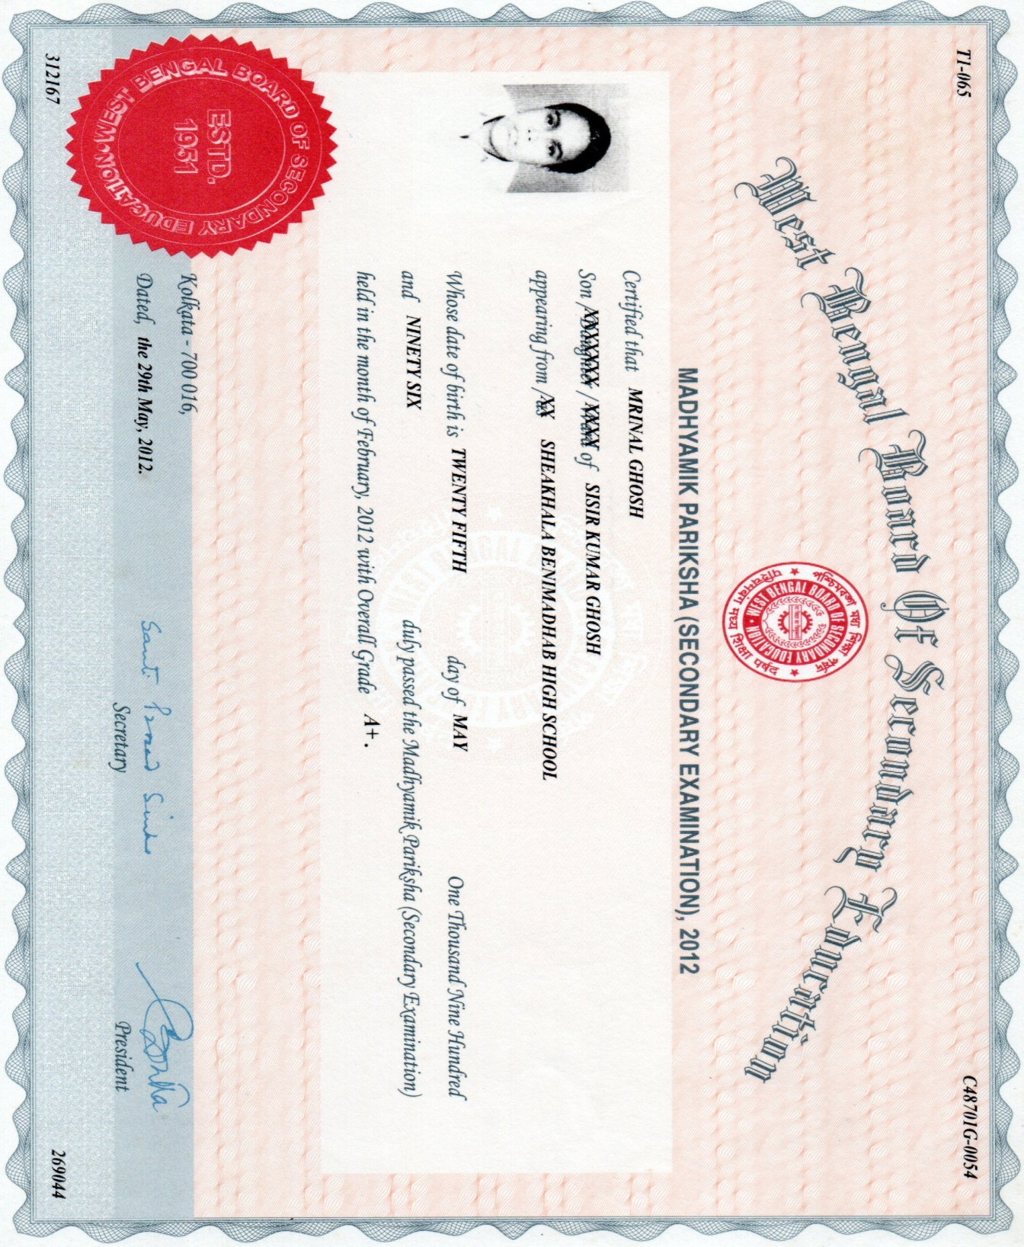

HIGHER SECONDARY RESULT :-
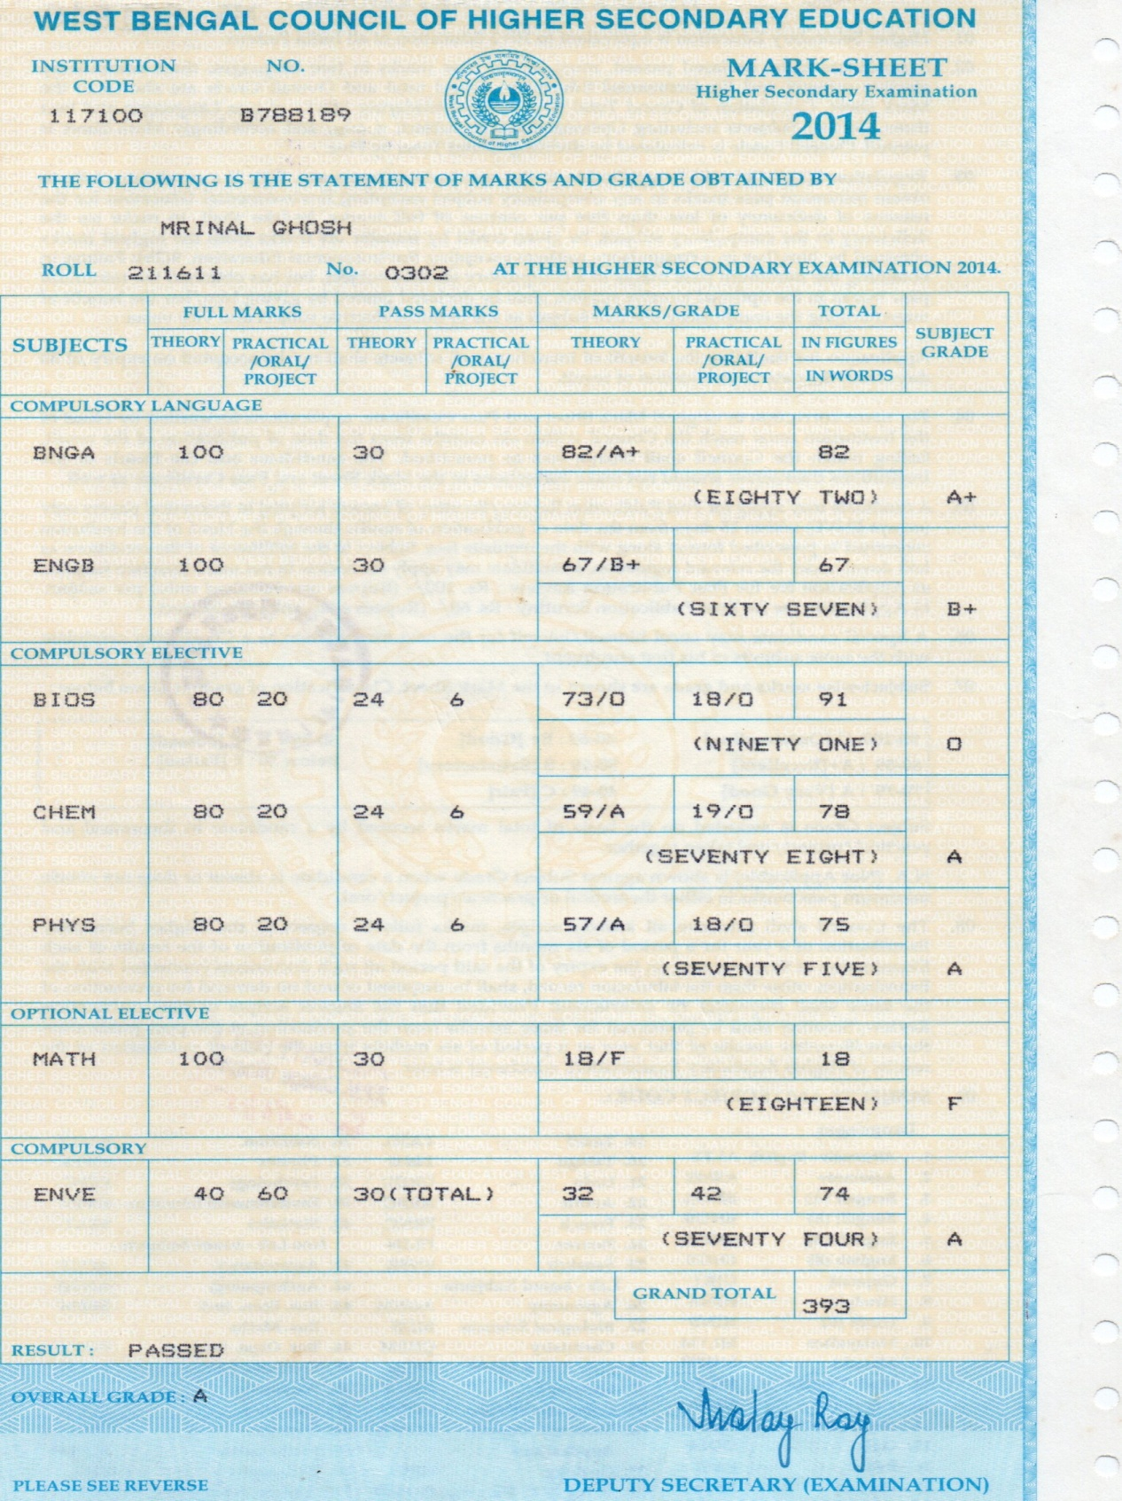

HIGHER SECONDARY CERTIFICATE :-
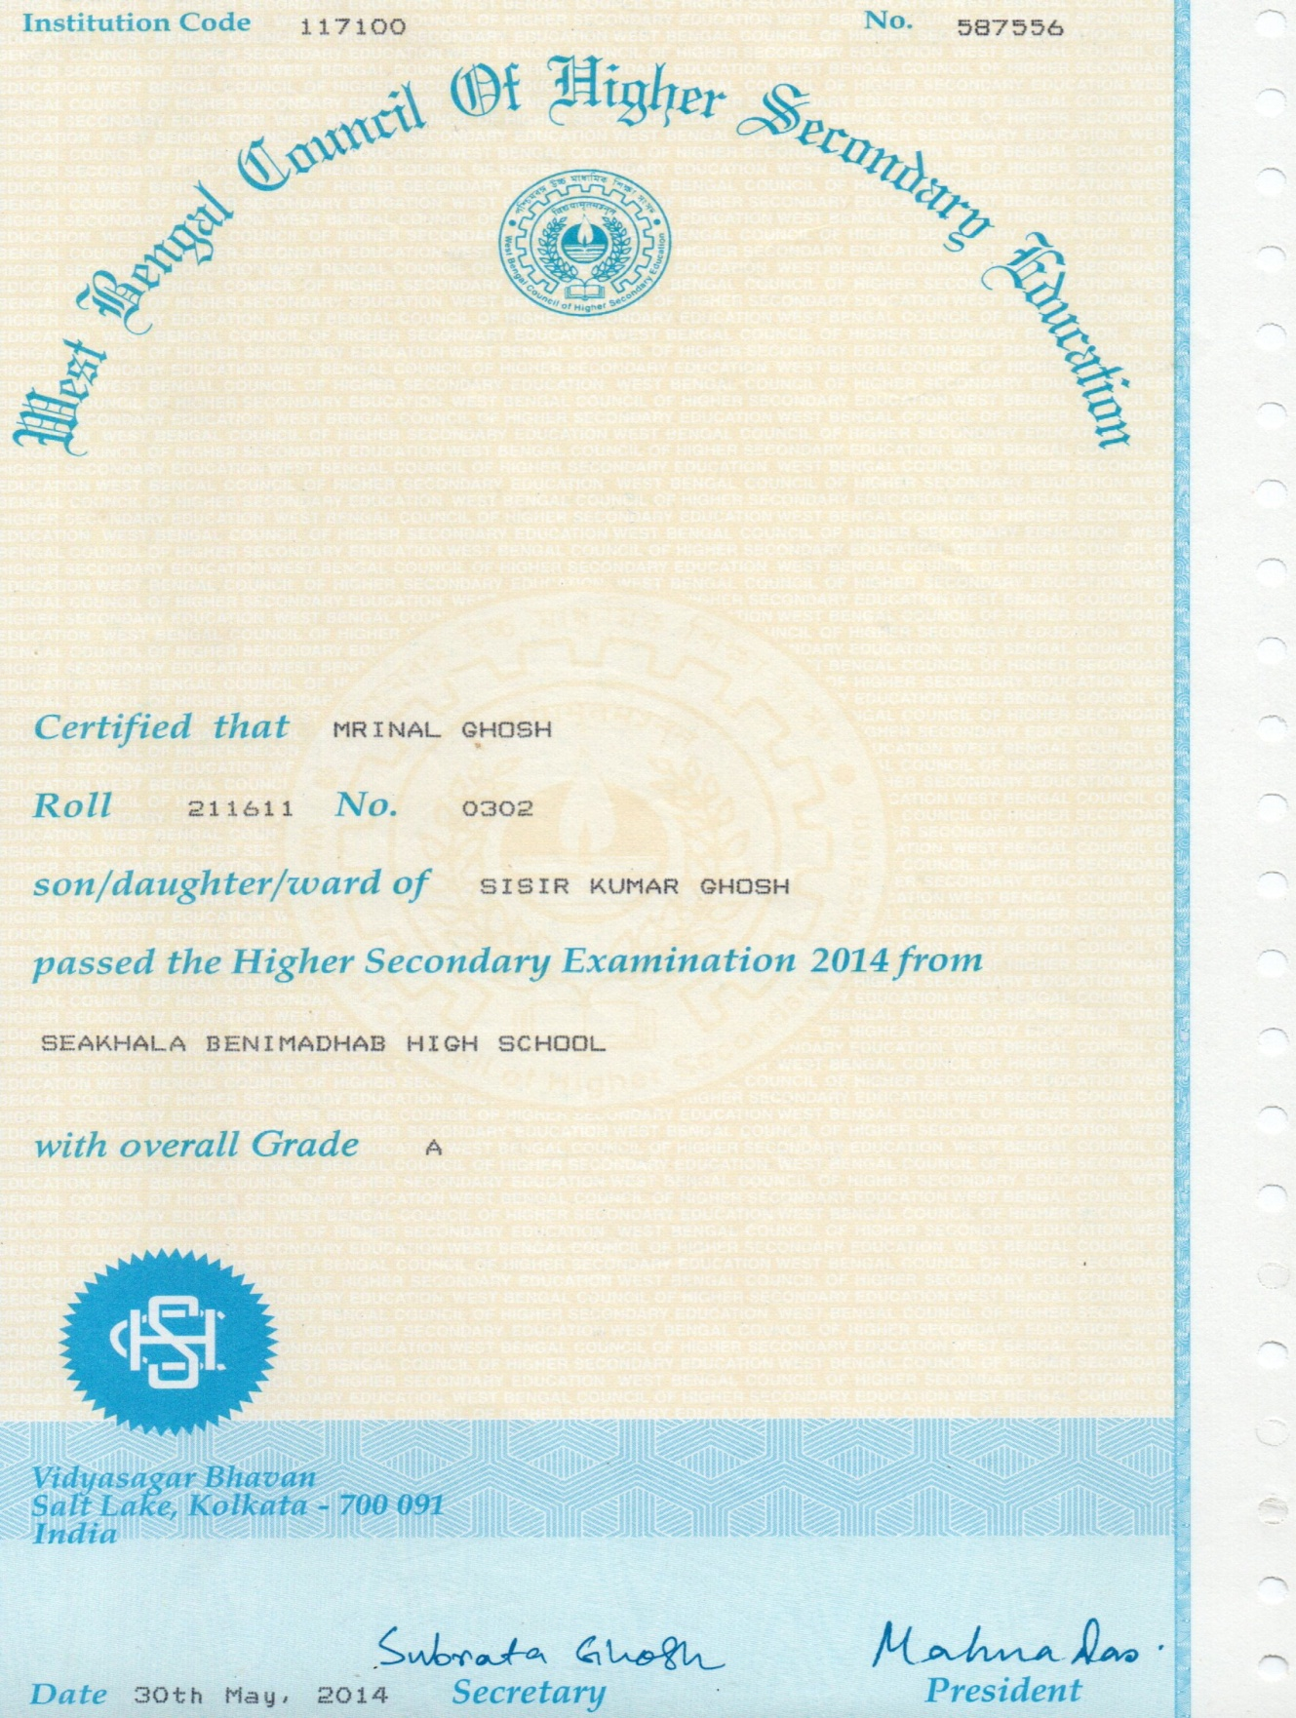

B.SC RESULT :-
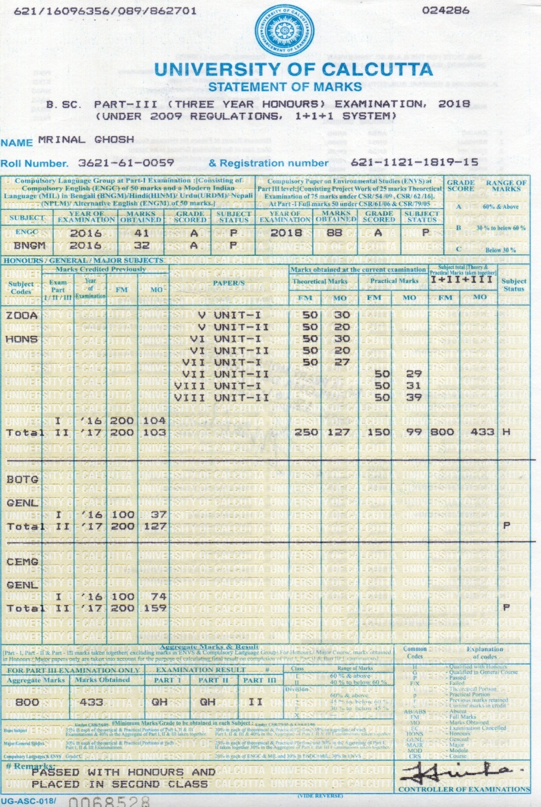

B.SC CERTIFICATE :-
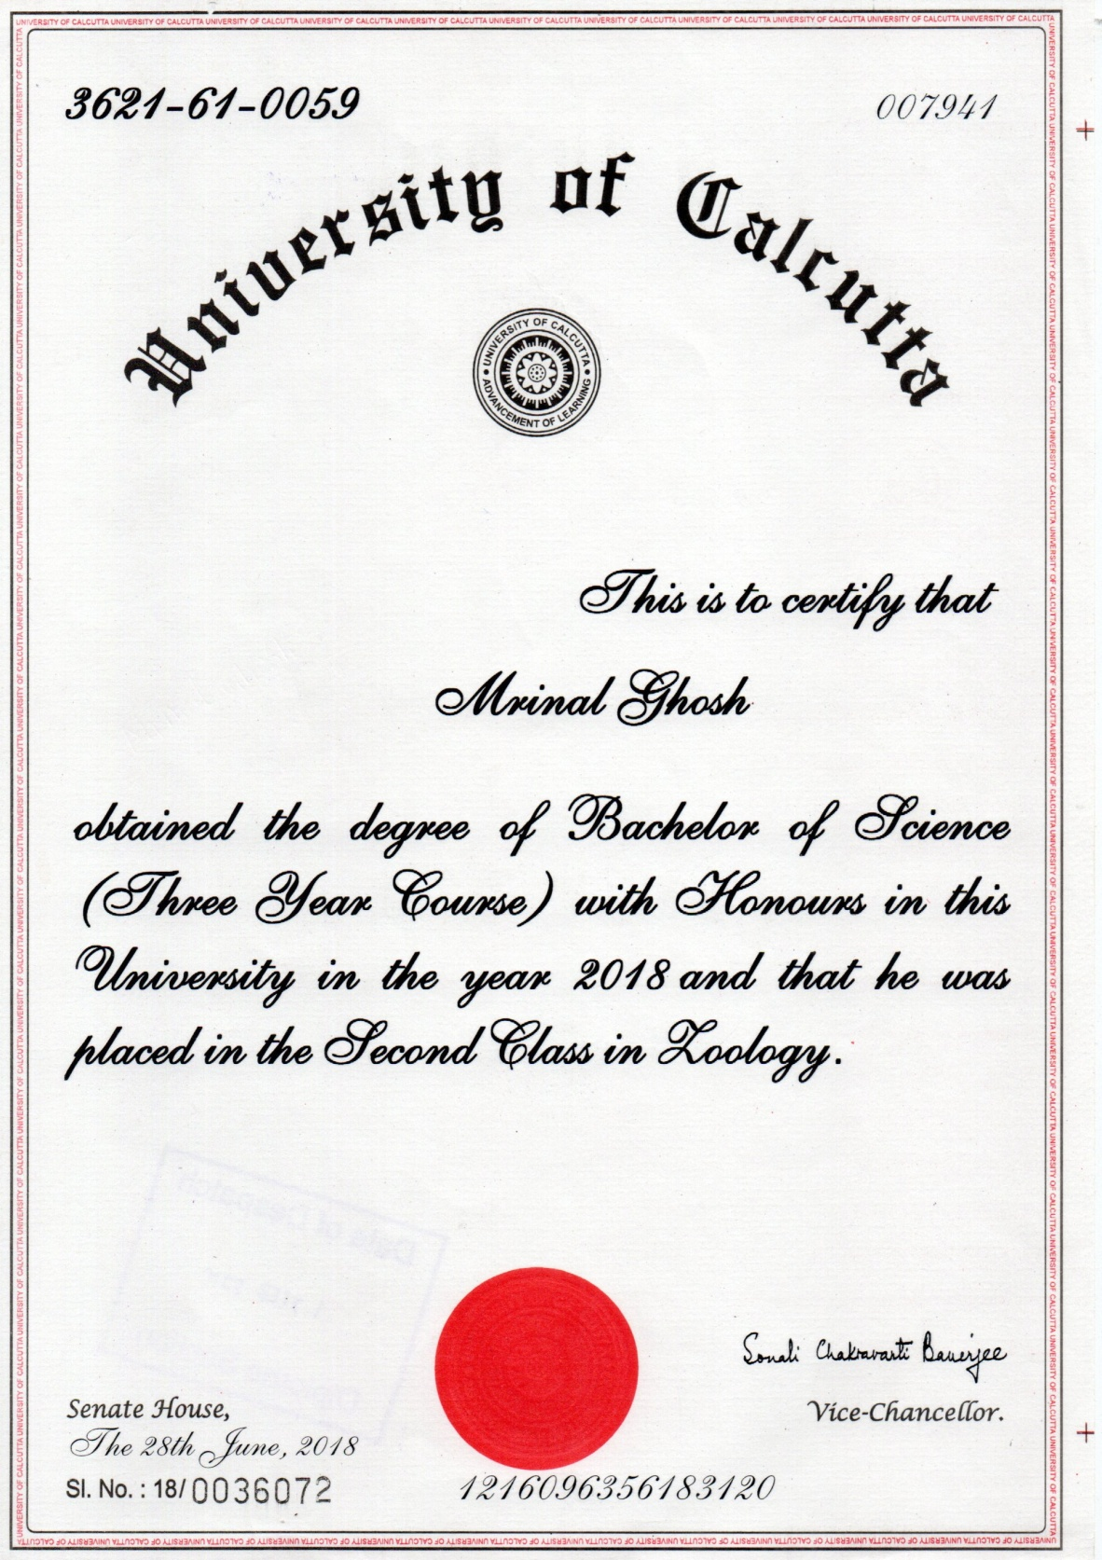

COMPUTER CERTIFICATE :-
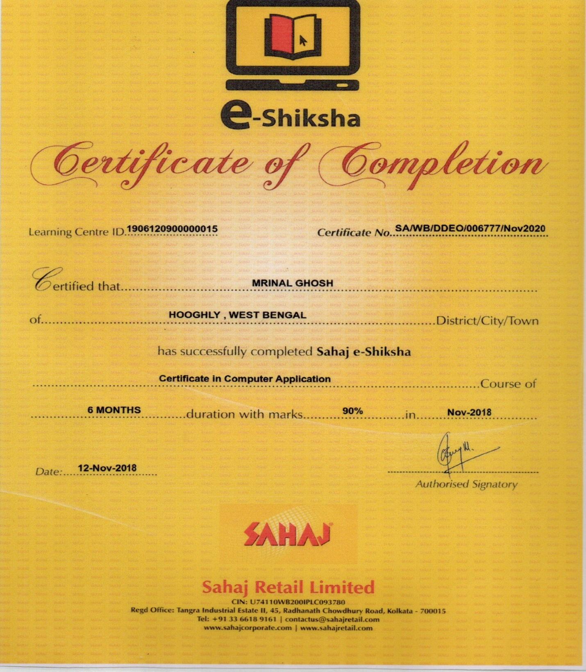

B.ED ADMISSION FORM:- 