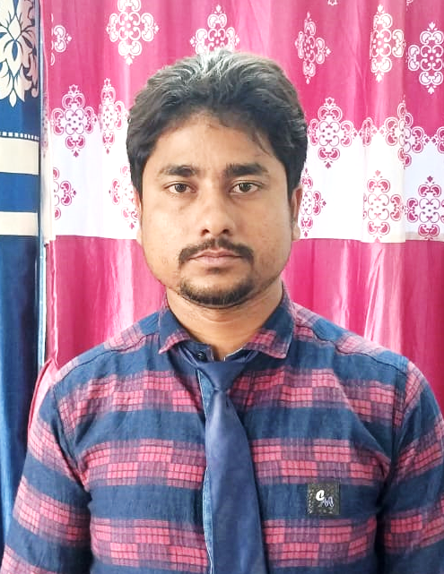
CURRICULUM VITAE

GURUPADA MANDAL

VILL+P.O – Sridharnagar, P.S - Gobardhanpur Coastal Dist. - South 24 parganas, Pin – 743371
Email - gurupadamandal597@gmail.com
Mob – 9641489148 / 8337823370

// ACADEMIC BACKGROUND

MADHYAMIK (W.B.B.S.E.)
Sridharnagar Sailendra Vidyapith (H.S)
60% in the year of 2012

HIGHER SECONDARY (W.B.C.H.S.E.)
Sridharnagar Sailendra Vidyapith (H.S)
67.4% in the year of 2014

GRADUATION (C.U.)
Patharpratima Mahavidyalaya Patharpratima
58.12% in the year of 2017

B.ED
W.B.U.T.T.E.P.A
C.G.P.A. – 8.90 in the year of 2021

// PERSONAL PROFILE

Father’s Name : Mr. Srikrishna Mandal
Date of Birth : 01.01.1995
Sex : Male Maritial Status : Unmarried Nationality : Indian
Hobbies : Playing cricket & Singing

// LANGUAGE KNOWN

Bengali English Hind
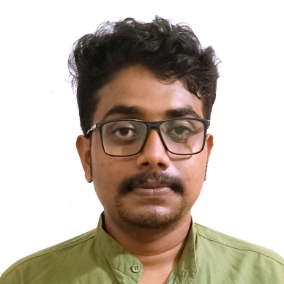
// JOB CAREER

Assistant teacher of Sanskrit and Mathematics
Namkhana Academy, Namkhana
Job duration from Nov 2019 to Jan 2021

Assistant teacher of Bengali and Hindi.
J.C. Memorial International School, Sagar Island
Joining at Jan 2021

