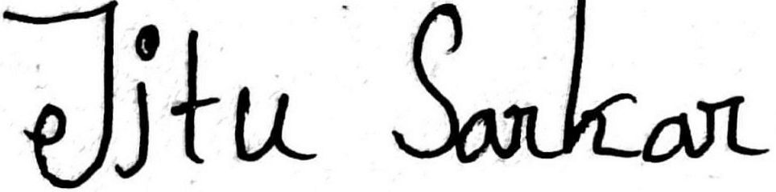
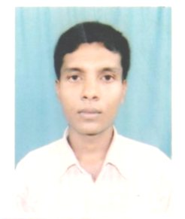
BIO-DATA
NAME : JITU SARKAR FATHER’S NAME : GOPAL SARKAR
PERMANENT ADDRESS : VILL-SERPUR P.O. –BUNIADPUR
P.S. -BANSHIHARI
DIST- DAKSHIN DINAJPUR
PIN-733121
WEST BENGAL
CONTACT NO. : 9932832791
DATE OF BIRTH : 20-SEP-1993
GENDER : MALE
NATIONALITY : INDIAN CAST : GENERAL
RELIGION : HINDU LANGUAGE KNOWN : ENGLISH ,BENGALI
EMAIL ID : jitusarkar1993@gmail.com
AADHAR CARD NO : 941729484269
EDUCATIONAL QUALIFICATIONS- :
Course /Degree | Board/University | Year of passing | PERCENTAGE%
M.P | W.B.B.S.E | 2010 | 60.00
H.S | W.B.C.H.S.E | 2012 | 72.20
B.A(HONS) | U.G.B | 2015 | 54.62
M.A | U.G.B | 2017 | 65.3

Date..........................
Place............................ Signature of applicant

