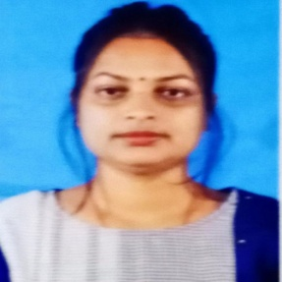
NAMITA SAMAJDAR
Habibpur,Malda,732122
namitasamajdar755@gmail.com 8918317824

CAREER OBJECT
EXPERIENCE QUALIFICATION

PERSONAL SKILLS

PERSONAL PROFILE

EXTRA QUALIFICATION
to be a part of progressive growth oriented organization through application of my skill knowledge

1 YEAR ENGLISH TEACHERS EXPERIENCE IN O2 PUBLIC SCHOOL.

W.B.B.S.E(BULBULICHANDIR.N.ROYGIRLSHIGHSCHOOL)
Madhyamikpassed 2015 — 460(65%)

W.B.C.H.S.E.(AIHOHIGHSCHOOL)
HS Passed
2017—415(83%)

UNIVERSITYOFGOURBANGA(MALDAWOMEN'SCOLLEGE)
Graduation 2021 —

English Honours 550(68%)

WBUTTEPA
B.Ed
2023—1762(88.1%)

Innovationandcreativethinking Leadership thinking
ComprehensionProblemsolvingability Hard work
Analyticalandinvestigatethinking Content writing
Copywriting

Father's Name - Subhash SamajdarMother'sName-AnjaliSamajdar Date Of Birth - 26/08/1997

Permanentaddress-
Vill-Habibpur,P.O-Habibpur,P.S-Habibpur,Dist-Malda,Pin-732122

Gender-Female
Marital status - Unmarried Relegian - Hinduism
Nationality-Indian

AdvanceDiploma(2 year)

Language Bengali,English,Hindi

Declaration
Idoherebydeclarethattheparticularofinformationandfactstatedhereinaboveare true,correctandcompletetothebestofthemyknowledgeandbelief
Signature:
NamitaSamajdar

