RESUME
NAME :AMIT SARKAR
FATHER’S NAME:DILIP KUMAR SARKAR
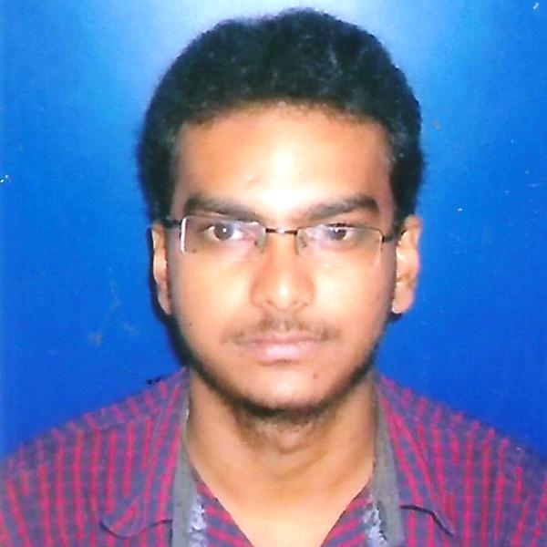
DATE OF BIRTH:04/04/1994

ADDRESS:
VILL.MAHESHPUR,BAGANPARA
PO.MOKDUMPUR
PS.ENGLISH BAZAR
DIST.MALDA
PIN-732103
WEST BENGAL
CONTACT No.7001070049
E-MAIL:amit.mayalove2013@gmail.com
EDUCATIONAL QUALIFICATION:
EXAM PASSED | NAME OF INSTITUTION | NAME OF BOARD | YEAR | MARKS(%)
MADHYAMIK | A.C.INSTITUTION | WBBSE | 2010 | 74.125
HIGHER SECONDARY | MALDA ZILLA HIGH SCHOOL | WBCHSE | 2012 | 76.8
B.SC(MATHEMATICS HONS.) | MALDA COLLEGE | UNIVERSITY OF GOUR BANGA | 2015 | 51.125
B.ED | VIVEKANANDA TEACHERS TRAINING COLLEGE | UNIVERSITY OF GOUR BANGA | 2017 | 73.5
M.SC | THE UNIVERSITY OF BURDWAN | THE UNIVERSITY OF BURDWAN | 2019 | 70.3
OBJECTIVE: To encourage creativity and higher-order thinking in a way that increases student performance.
EXTRA QUALIFICAFION:
1 Year diploma in computer application.
HOBBIES:Cricket And Traveling.
LANGUAGE KNOWN:BENGALI, ENGLISH, HINDI.
NATIONLITY: Indian
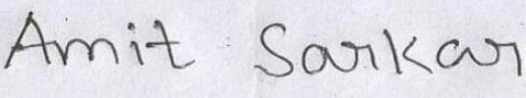
RELIGION: Hinduism
CASTE: SC

Date:……………… Signature
Place:……………...

