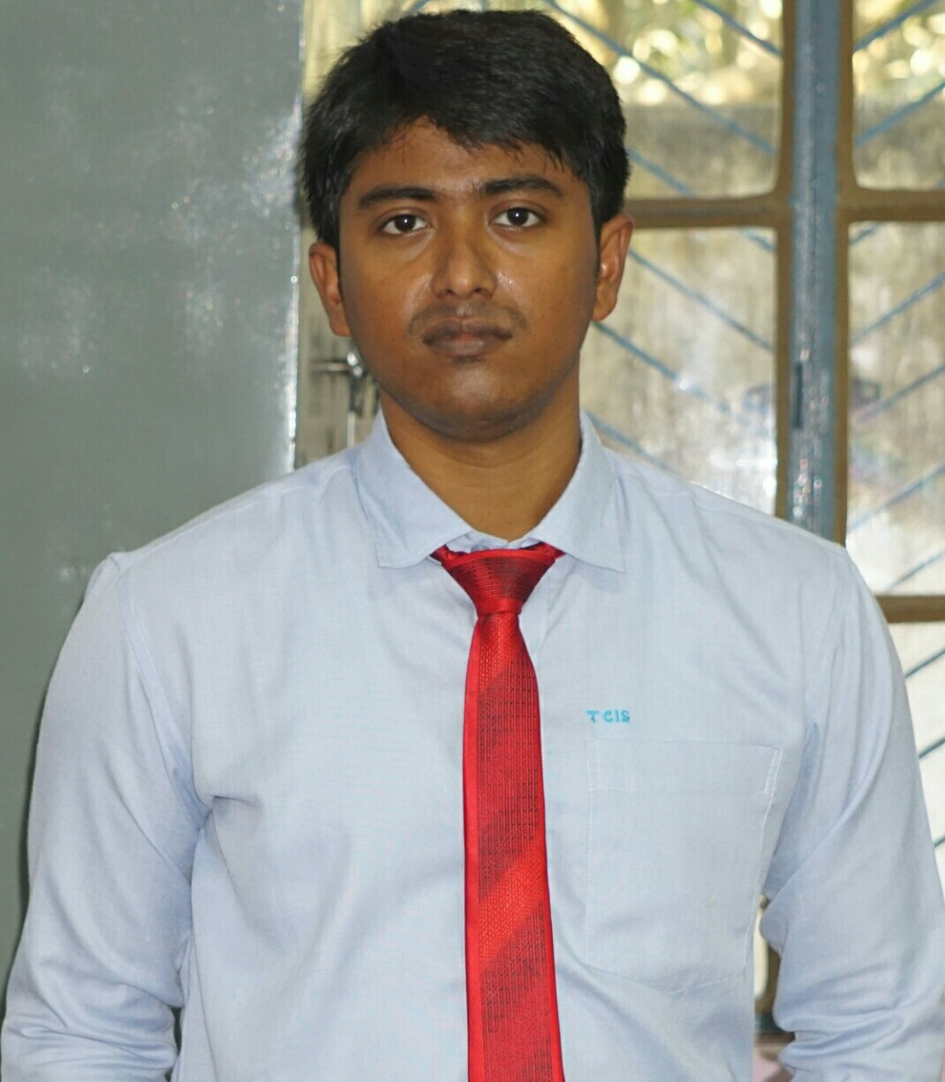
CURRICULUM VITAE

NAME : RABBI IKBAL SARKAR
FATHERS NAME : HAMIDUR SARKAR
MOTHERS NAME : AFRUJA SARKAR
ADDRESS : VILL: BARAMPUR, P.O- CHAKBALIRAM
P.S: TAPAN, DIST- DAKSHIN DINAJPUR
PINCODE: 733127
PHONE NUMBER : 8617034416
DATE OF BIRTH : 28/03/1993
SEX : MALE
NATIONALITY : INDIAN
RELIGION : MUSLIM
MARITAL STATUS : MARRIED
EMAIL : rabbiikbalsarkar24@gmail.com

ACADEMIC QUALIFICATION:
NAME OF EXAMINATION | BOARD/  UNIVERSITY | YEAR. | PERCENTAGE | DIVISION
MADHYAMIK | W.B.B.S.E | 2008 | 66.25 | 1ST
HIGHER SECONDARY | W.B.C.H.S.E | 2010 | 63 | 1ST
BACHELOR OF ARTS | U.G.B | 2013 | 49.37 | 2ND
M.A | P.U | 2015 | 65.31 | 1ST
B.ED | U.G.B | 2017 | 76.5 | 1ST
D.El.Ed | NIOS | 2019 | 73.5 | 1ST
LANGUAGES KNOWN:
LANGUAGES | SPEAK | READ | WRITE
BENGALI (Mother Tongue) | Y | Y | Y
ENGLISH | Y | Y | Y
HINDI | Y | Y
COMPUTER SKILLS: Diploma in Office application and Management (DOAM), Diploma in Computer Application(DCA).
OTHER QUALIFICATION: Counseling Experience, programs organizer, Sports activities, 4 working as a cultural head at Tarbiyah Cambridge international school.
CO-CURRICULAR ACTIVITIES: NSS
EXPERIENCE: 2 Years working as a board co ordinator(IX-XII) and 6 years working experience as a Assistant teacher & Counseling department experts in Tarbiyah Cambridge International School (CBSE BOARD) at Baranagar, Danga, Jalalpur, Malda.

Declaration:
I hereby declare that the above-mentioned information is correct to the best of my knowledge and I bear the responsibility for the correctness of the above-mentioned particulars.

Place:
Date:

RABBI IKBAL SARKAR.

