0
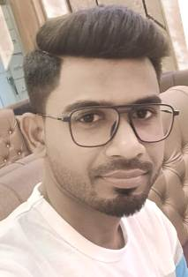

SOMNATH PRAMANIK

CONTACT
 9563129696
 somnath00092@gmail.com
 VILL+P.O-NAGESWARPUR P.S-MALDA, DIST-MALDA PIN-732142
EXPERTISE SKILLS
- 1 YEAR DIPLOMA IN COMPUTER
- WEST BENGAL VOCATIONAL COURSE IN TELEPHONE & MOBILE SET REPAIRING

LANGUAGE

ENGLISH

HINDI

BENGALI

INTEREST

TRAVELLING

BOOKS
1.
PROFESSIONAL PROFILE

Seeking a challenging career in dynamic and leading,
Cultivate and nurture my skills with opportunity to display my
Talent and become an asset to the Organization.
EDUCATION
2.

- WEST BENGAL BOARD OF SECONNDARY EDUCATION

MADHYAMIK
60.62%
- WEST BENGAL COUNCIL OF HIGHER SECONDARY EDUCATION

HIGHER SECONDARY
52.40%
- UNIVERSITY OF GOURBANGA

GRADUATION IN ENGLISH
47.33%

EXPERIENCE

3.

10 YEARS TEACHING EXPERIENCE AS PRIVATE TEACHER
DATA ENTRY OPERATOR

DATE:- SIGNATURE

