BIO DATA

Passport Size Pho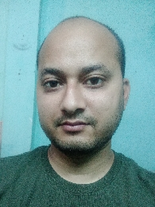to
Name : BISWAJIT BARMAN
Father’s / Husband’s Name. : BISWESWAR BARMAN
Date of Birth : 27/12/1993
Gender : MALE
Married / Unmarried : UNMARRIED
Languages Known : BENGALI
Permanent Address : VILL- DURACHAPRI, P.O- NIGAMNAGAR, P.S- SAHEBGANJ, DIST- COOCHBEHAR, STATE - WEST BENGAL ,PIN NO- 736169.

Correspondence Address : VILL- LENINPUR, P.O- KADAMTALA, P.S- MATIGARA, DIST- DARJEELING, STATE- WEST BENGAL, PIN NO- 734012

Email Id : biswajitnbu123@gmail.com
Mobile No :8515826401
Category (SC/ST/BC/OBC/General) :SC
Religion :HINDU
Educational Qualification :

Name of the Exam | Year of Pass | Board/University Name | Full Marks | Marks | Percentage
M.P | 2010 | W.B.B.S.E | 800 | 485 | 60.62
H.S | 2012 | W.B.C.H.S.E | 500 | 322 | 64.40
B.A | 2015 | N.B.U | 800 | 388 | 48.50
M.A | 2017 | N.B.U | 1600 | 850 | 53.13
B.Ed | 2019 | W.B.U.T.T.E.P.A | 2000 | 1476 | 73.80
D.C.A | 2014 | R.C.L.D | 100 | 94 | 94

Declaration: I hereby declare that all the above information is true to the best of my knowledge.

Date :
Place : Signature

