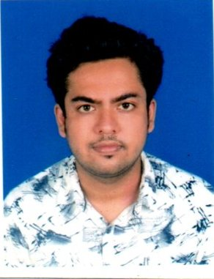
BIO DATA

NAME: - SOUVIK KUMAR SINHA

CURRENT & PERMANENT ADDRESS
ADDRESS:- REGENT PARK
P.O. + DIST:- MALDA
P.S.:- ENGLISH BAZAR.
PIN:- 732101
CONTACT NO: - 9051834971
EMAIL ID: -souvikkumar5678@gmail.com

PERSONAL PROFILE

FATHER’S NAME :- BIPLAB KUMAR SINHA
DATE OF BIRTH: – 28/01/1997
SEX: – MALE .
CATEGORY :- GENERAL
NATIONALLY: - INDIAN.
MARITAL STATUS: - UNMARRIED.
LANGUAGES KNOW: - BENGALI, ENGLISH & HINDI.(Read & Write)

ACADEMIC QUALIFICATION
S.L | EXAMENITION  PASSED/DEGREE/DIPLOMA | BOARD / UNIVERSITY | PERCENTAGE OF MARKS
1 | MADHYAMIK | W.B.B.S. EDUCATION | 82.28%
2 | HIGHER SECONDARY | W.B.C.H.S. EDUCATION | 60%
3 | B.Sc (H) in Microbiology | ADAMAS UNIVERSITY | 6.34 CGPA/ 63.23%
4 | B.Ed | SatisB.ed College | 83.05%
5 | Msc | RadhaGovind University | 78%
6 | Bihar stet |  | Qualified

- INTERNSHIP : One Month Internship on Food Microbiology ( Quality Control of Milk ) From SHRM BIOTECHNOLOGY PVT. LTD.
- Specialization: CERTIFICATE COURSE IN INFORMATION TECHNOLOGY APPLICATION
- [ 6 MONTH DURATION COURSE ] FROM MALDA SADAR YOUTH COMPUTER TRAINING CENTRE

- PROJECT REPORT : INVESTIGATION THE RELATIONSHIP BETWEEN PLAYING VIDEO GAMES AND ATTENTION AMONG YOUNG ADULTS - A Pilot Survey In Adamas University Campus . [ Unter Mentorship of Dr. NELOY KR CHAKRABARTI _ neloykumar@gmail.com ]

- SEMINAR : 1)INFLUENCE OF MICROBIOLOGY IN HUMAN HEALTH
2) IMPACT OF MICROBES ON ENVIRONMENT AND SOCIETY

Specialization :
- One month laboratory Apprenticeship program (internship) in medical microbiology from Sneho Diagnostic Centre, Malda . [ Under guidance of Dr. ParthaSarathi Roy. ( Professor of govt. Medical college)]
- Certificate of Participation on "Application of Biometrical Techniques in Plant Breeding Selection", organised by the Department of Agricultural Sciences, RadhaGovindUnversity, Ramgarh .
- Teaching experience - More than 5 years .
- Preference of Subject for teaching - Biology ( upto class 12 ) + Neet level
Physics ( upto class 10 )
Chemistry ( upto class 12 )
Math ( upto class 10 )

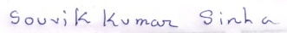
DATE-
SIGNATURE

