- CURRICULUM VITAE

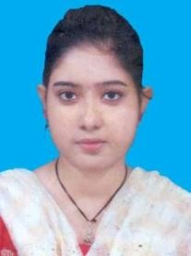
EKTA SARKAR
D/O – BAPPADITYA SARKAR
Mob- 6297902235
Email Id –ektasarkarsen@gmail.com
___________________________________________________________________
Objective:
To contribute my level best to myself whatever through a part of a team or individual to achieve the peak of the goal of the organization. I work

Academic Qualification:
Name of The Examination | Name of the Board | Year of Passing | Full  Marks | Total  Marks  Obtained | % of Marks
M.P | W.B.B.S.E | 2011 | 800 | 519 | 64.87%
H.S | W.B.C.H.S.E | 2013 | 500 | 275 | 55%
B.SC | U.G.B | 2017 | 800 | 401 | 50%
M.SC | U.G.B | 2019 | 1000 | 625 | 62.5%
B. Ed | WBUTTEPA | 2021 | 2000 | 1778 | 88.9%

Personal Details:
Date of Birth: 15.02.1995
Gender:Female
Nationality: Indian
Languages Know: Bengali, Hindi, English
Religion :Hindu
Permanent Address: Vill: Madhabnagar , PO: English Bazar PS : Malda
Dist :Malda, Pin: 732101
DECLARATION:
I hereby declare that the above furnished details are true and correct to the best of my knowledge and belief.

Date:_________ __________________
Place:_________ Signature

