-:CURRICULAM VITAE:-

SURABHI RANI SINGHA.
Contact No:-(0)80015-62697(M) / (0)94346-81819(M)
e-mail: - surabhiranisingha99@gmail.com.
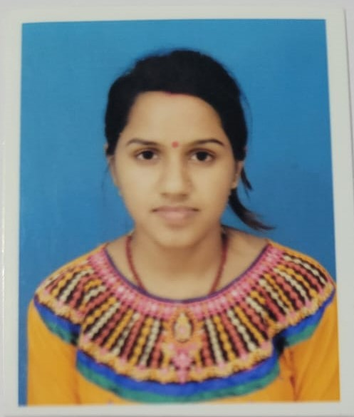

PERMANENT ADDRESS:
C/O:- Amit Kumar Singha.
Village: - Krishnapally Bapuji Colony, Malda.
P.O. - Malda.
P.S.:- English Bazar.
Dist.: - Malda.
Pin:- 732101.
State:- West-Bengal.

PERSONAL DETAILS:
Father’s Name : Late Rabindra Kumar Singha.
Mother’s Name : Khuku Singha.
Husband’s Name : Amit Kumar Singha.
Date of Birth :20.12.1999.
Marital Status : Married.
Religion : Hinduism.
Nationality : Indian.

OBJECTIVE:
To Be Part of A Company And Gather All Experience Through Hard And Dedicated Work That Will Mold My Carrier And Drive Me To The Top In The Long Term.

PERSONAL STRENGTH:
Self Confident & Hard Working Ability.

ACADEMIC QUALICATION:

EXAM. | BOARD/UNIVERSITY. | YEAR OF PASSING. | PERCENTAGE.
Secondary. (All) | W.B.B.S.E. | 2015 | 75.85%
Higher Secondary.  (Science.) | W.B.C.H.S.E. | 2017 | 74.80%
Bachelor of Computer Application | Gour Banga University | 2020 | 1st Sem - 69.66%  2nd Sem- 48%  3rd Sem - 58%  4th Sem–62.66%  5th Sem- 85.66%  6th Sem- 91.66%
B.Ed | Uttarbanga Womens’ B.Ed College | 2020-2022 | CGPA – 10.00
Diploma in Networking and Hardware Engineering | West Bengal State University | 2022-2024 | 89.60 %

LANGUAGE KNOWN:
Bengali: - : Read, Write& Speak.
English: - : Read, Write& Speak.
Hindi :- : Read & Speak.

SKILLS:
- Ability To Judge, Creativity and Self Confidence.

- Good Conduction.

- Advanced MS Word, MS Excel, MS Power Point.

- Known Computer Languages (C, C++, Java, HTML, CSS, Javascript, Python).

HOBBIES AND INTEREST:
Singing and Internet Surfing.

EXPERIENCE:

- 3 months experience in Marketing in Reliance – Jio.
- Worked as a Math and Computer Teacher at St. Chistiya English Medium School.
- Working as a Computer Teacher at Swami Vivekananda Academy (High School).
- Working as a Private Tutor since 2017.

DECLARATION:
I hereby declare that the above-mentioned information is correct up to my knowledge and I bear the responsibility for the correctness of the above-mentioned particulars.

Date:
Place: Malda

Surabhi Rani Singha

Signature

