BIODATA

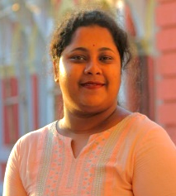
NAME :- SUSMITA SUTRADHAR
FATHER'S NAME :- SHYAMAL SUTRADHAR
MOTHER’S NAME :- ARATI SUTRADHAR
ADDRESS :- CHHATGURIAHATI, NEW TOWN, DINHATA ROAD, P.O + DIST. – COOCHBEHAR
P.S – KOTWALI , PIN – 736101
QUALIFICATION
NAME OF EXAM | BOARD | YEAR OF PASSING | DIVISION | MARKS OBTAINED | PERCENTAGE OF MARK OBTAINED
MADHYAMIK | WBBSE | 2014 | 2ND DIV. | 327 | 46.7%
HIGHER SECONDARY | WBCHSE | 2016 | 1ST DIV. | 315 | 63%
GRADUATION (BENGALI HONORS) | NSOU | 2021 | 1ST DIV. | 584 | 73%
BLIS (BACHELOR OF LIBRARY & INFORMATION SCIENCE) | CBPBU | 2023 1ST DIV |  | 552 | 69%

EXTRA QUALIFICATION – DIPLOMA IN ADITA (COMPUTER )

GENDER – FEMALE
RELIGION – HINDUISM
DATE OF BIRTH - 09.10.1997 PHONE NO. – 9382460979
CASTE - OBC- B
LANGUAGE – BENGALI, HINDI, ENGLISH EMAIL – Susmitadhar03@gmail.com

