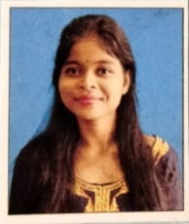
VILL-CHOWDHURY GACHH
P.O- CHOPRA
P.S- CHOPRA
DIST- NORTH DINAJPUR
PIN- 733207

CURRICULAM VITAE

PRIYA HEMBROM
OBJECTIVE:
Aspire for a career which provides me with continuous learning opportunities through exposure to different of situation and environment.

PERSONAL DETAILS
FATHER’S NAME : SUSHIL HEMBROM
DATE OF BIRTH : 15-07-2000
PHONE NO : 6294253940
E-MAIL : priyahembrom7@gmail.com
NATIONALITY : INDIAN
RELIGION : CHRISTIAN
LANGUAGES KNOWN : BENGALI,HINDI,ENGLISH
HOBBIES : READING, DANCING

EDUCATIONAL QUALIFICATION
Examination  Passed | Year of Passing | Name of Board  / University | % of Marks | Divn./Grade
MADHYAMIK | 2016 | W.B.B.S.E | 59% | A
H.S | 2018 | W.B.C.H.S.E | 88% | A+
GRADUATION | 2021 | NORTH BENGAL | 69% | A
B.ED | 2023 | BABA SAHEB AMBEDKAR EDUCATION UNIVERSITY | RUNNING | RUNNING

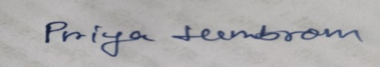
DECLARATION : I do hereby declare that all the information are true to the best of my knowledge and belief.
Place:- CHOPRA
Date :- Signature of the Candidate

