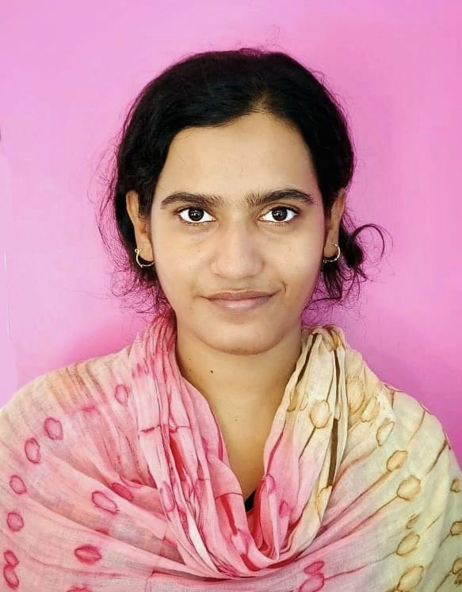
Curriculum Vitae
NAME : RESHMI MANDAL
FATHER'S NAME : L'T. MATIUR MANDAL
MOTHER'S NAME : JAHANARA BEWA
DATE OF BIRTH : 15/01/1994
SEX : FEMALE
RELIGION : ISLAM
CASTE : GENERAL
MARITAL STATUS : UNMARRIED
NATIONALITY : INDIAN
PERMANENT ADDRESS : VILL:- HINDU PARA, BARA SUJAPUR,
P.O:- SUJAPUR, P.S:- KALIACHAK, DIST:- MALDA,
PIN:- 732206, STATE:- WEST BENGAL
CONTACT NUMBER : +91-8617896103 / 8370985755
E-mail ID : reshmini075@gmail.com
LANGUAGES KNOWN : ENGLISH, BENGALI & HINDI (Can read, write,
& speak fluently)
EDUCATIONAL QUALIFICATION :
Exam. Passed | Board | Passing  Year | Total Marks | Marks Obtained | Percentage  (%)
Madhyamik | W.B.B.S.E | 2009 | 800 | 617 | 77.12
H.S. (Bio Science) | W.B.C.H.S.E | 2011 | 500 | 329 | 65.80
B.A. English Honours | I.G.N.O.U. | 2019 | 1200 | 696 | 58.00
B.Ed (English) | WBUTTEPA | 2022 | 2000 | 1898 | 94.90(10 CGPA)
M.A.( English) | I.G.N.O.U. | 2023 | 800 | 514 | 64.25
CAREER OBJECTIVE : Involved with teaching for more than 5 yrs and preparing for various
competitive exams.
Would like a challenging yet fulfilling post regarding to education.
SKILLS : Enthusiastic, Energetic, Adaptable & Friendly. Willingness to learn.
Effective Communication skills. Good time Management.
EXPERIENCE : 5 years of teaching. (Elementary & Secondary level private school)
Declaration: I hereby declare that the above-mentioned information is correct up to my knowledge and I bear the responsibility for the correctness of the above-mentioned particulars.
___________________
Signature

