Curriculum Vitae
Name : CHHOTON SARKAR
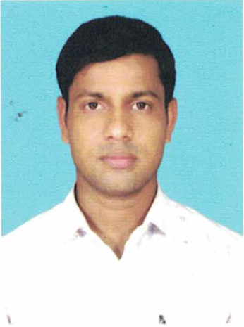
Information Father’s Name : NARAYAN SARKAR
Personal Date of Birth : 15/02/1992
Mobile No. : 9733463258
e-Mail Id : chhotonsarkar92@gmail.com
Marital Status : Single
Nationality : Indian
Academic Qualification
- Passed Madhyamik in the year of 2009 with 51% from W.B.B.S.E.
- Passed Higher Secondary in the year 2012 with 39% from W.B.C.H.S.E.
- Passed B.A. (PASS) in the year 2016 with 44% from U.G.B.
Technical Skill
- Basic Knowledge of Computer
- Microsoft Excel and Word
- Having good presentation skill using Power Point
- Sound knowledge of photo editing use of Photoshop
- All online activates, including various examination from fill up, ticket booking etc.
Experience
- Fresher
- Yoga and Athletics teaching
Hobbies
- Listening Music
- Use Computer
- Sports (Yoga, Badminton, Rokit Ball, Khokho, Kabaddi, March-pase, Athletics)
Language Known
- Bengali Read Write Speak
- English Read Write ……..
- Hindi Read ……. Speak
Address
Present & Permanent Address
Vill : New 16 Mile P.O. : Gurutola
P.S. : Baishnabnagar Dist : Malda
State : West Bengal Pin : 732127
Objective
To get a chance to work & utilize my knowledge and capabilities by working in a dynamic organization that prides it’s in giving substantial responsibility to new talent.

Place : Signature
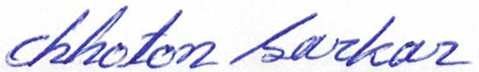
Date :

