Sumana Ray
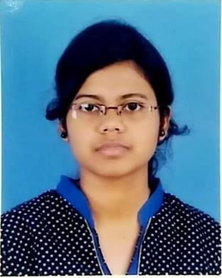
Passionate, Enthusiastic, Confident

Academics –

- Barlow Girls’ High School(Malda,WB) Personal details-
- Secondary(10th) DOB- 12th feb 1998
- Year-2014 Sex-female
- Percentage-69 Caste- Hinduism

- Barlow Girls’High School (Malda,WB) Languages-
- Higher Secondary(12th) 1.Bengali(Mother tongue)
- Year-2016 2.English(Speak,read,write)
- Stream-Arts 3.Hindi(Speak & read)
- Percentage-82.40

3.Malda college (Malda,WB) Skills
- Bachelor of Arts(B.A) Passionate
- Year-2019 Enthusiastic
- Honours in Bengali Literature Fast learner
- Percentage-60.12 Communication skill
Time management
- UNIVERSITY of GOUR BANGA (Malda,WB) Team management
- Master of Arts(M.A) Confident
- Year- 2021 Friendly
- Masters in Bengali language & literature Tolerant
- Percentage-68.41 Calm

Additional qualifications Hobby & Interest
Diploma at computer application(DCA ) 1. Writing articles
Typing speed-35wpm 2. Reading literature
3. Cooking
4. Giving Honorary tuition

Contact details
Address-South Ramkrishnapally,Malda(WB)
Malda- 732101
- Mobile-8509483618
- Email- sumanaray100@gmail.com
- Whatsapp-9091096358

“I Sumana Ray hereby declare that all the information provided by me is correct, true and valid. I will present the supporting documents as and when required.
Sumana ray
Date- 26.01.23

