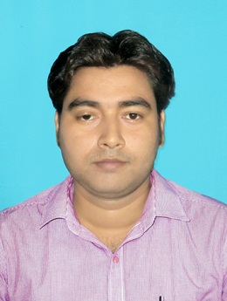
RESUME

NAME : BISWAJIT SARKAR
CONTACT NO : 9547111842
EMAIL ID : pv.biswajit.kitu@gmail.com
RESIDENTIAL ADDRESS : Vill. – Jahangirpur,
PO- Jahangirpur, PS- Kotwali,
Dist.- Nadia, Pin- 741103

OBJECTIVE
Looking for an opportunity where I can utilize my knowledge and skills for my and company’s future growth

EDUCATIONAL QUALIFICATION
NAME OF EXAMINATION | UNIVERSITY / COUNCIL / BOARD | YEAR | % OF MARKS
Madhyamik | W.B.B.S.E. | 2007 | 65%
Higher Secondary | W.B.C.H.S.E. | 2009 | 73%
Graduation (Snsk .Hons.) | University of Kalyani | 2012 | 68.5%
M.A. (Snsk. ) | Jadavpur University | 2014 | 52%
B.Ed. | University of Kalyani | 2015 | 78%
M.A. (Education) | N.S.O.U. | 2018 | 66%

ADDITIONAL QUALIFICAITON
- Advance Diploma In Computer Application (18 months).

EXPERIENCE
- 1 year experience as a Guest Lecturer in Renuka Devi D.El.Ed. college.
- 2 years’ experience as a Head Master in Pranabananda Vidyapith High School organized by Bharat Sevashram Sangha at Aurangabad, Murshidabad.

EXTRA CURRICULUM ACTIVITIES
- Speaking Power, Debate, Energetic,

COMPUTER SKILLS
- MS Office package, Windows 7, 10, Internet.

LANGUAGE KNOWN
- English
- Bengali
- Hindi

PERSONAL INFORMATION
FATHER’S NAME : Goutam Sarkar
MOTHER’S NAME : Bandana Sarkar
DATE OF BIRTH : 19th March, 1990
NATIONALITY : Indian
RELIGION : Hinduism
CAST : General
MARITAL STATUS : Married
GENDER : Male
HOBBY ; Reading Books, Traveling new places.

DECLARATION :
I hereby declare that all the statements made in this application is true and correct I also understand that in the event of any statement furnished or documents attach is / are found false or in correct, it should this qualify my candidature and if detected after my appointment, my service will be liable to be terminated without notice.

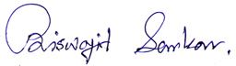
Date : 25.12.19
Place : Krishnagar

Signature

